Dashboard Simulation

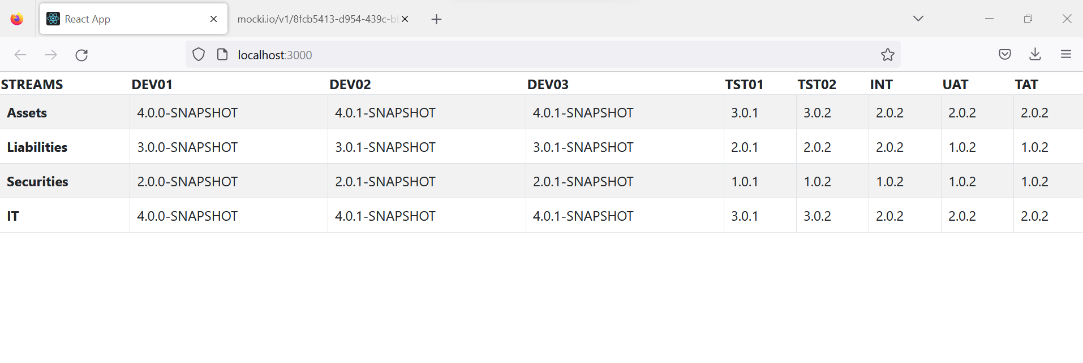

Mock Json response based on which the above display is rendered

